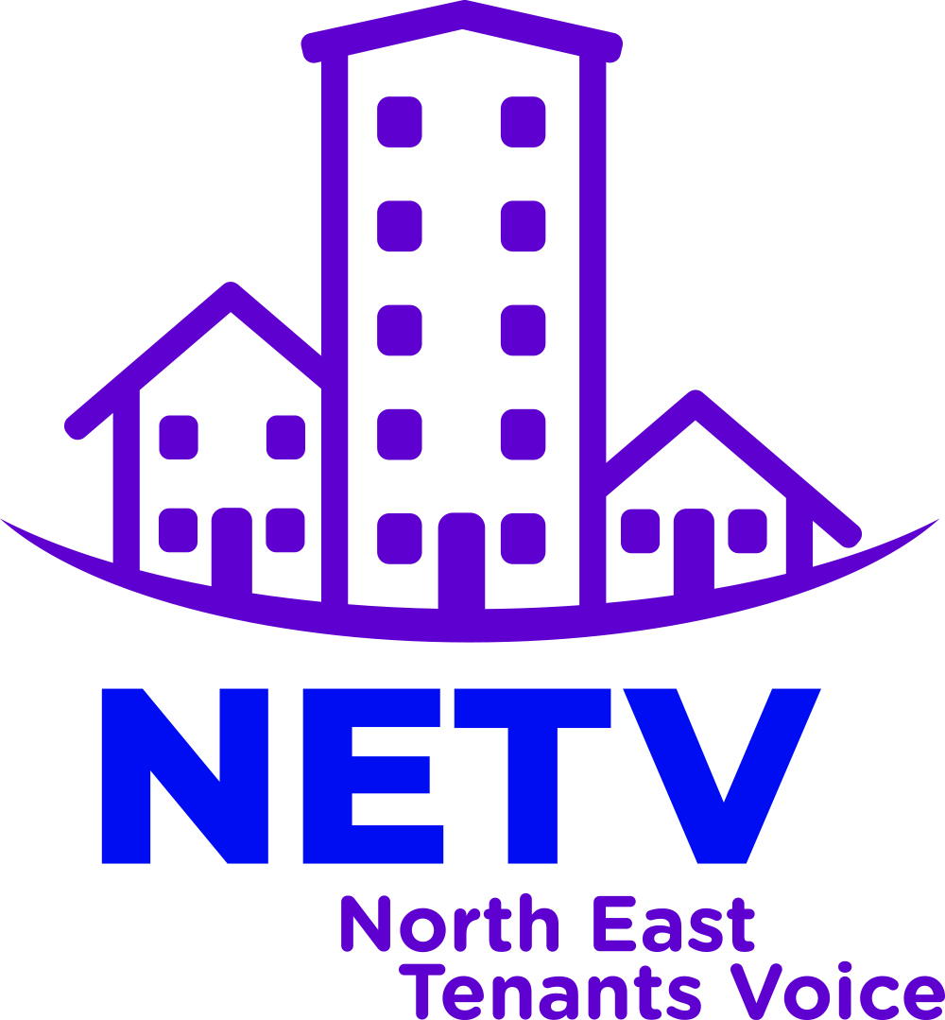

Tackling Stigma Briefing

North East Tenants Voice
Introduction
Tpas has facilitated the creation of four specialist groups as sub-groups to the collective North East Tenants Voice to explore four key priority areas using the following three questions as a basis to form their response:
- What current action is being taken on this key priority?
- What resources can be accessed or what areas of the sector can help raise the profile of this priority?
- What role could NETV have in responding to the key priority locally, regionally and nationally?

This briefing paper comprises of the findings produced by the ‘Tackling and reducing Stigma’ specialist sub-group.

- What current action is being taken on this key priority?

It is clear that tackling stigma is an ongoing issue for which there is no quick fix and involves monumental involvement and development from Residents and Landlords, Governments and whole communities. We found that there has been a lot of talk and repetition within documents and policies about what the tenants want, and we need to use the NETV to support further physical action on the elements that have been repeatedly identified in recent years, now that stigma has been established as existing and defined. We need to look at what successful action might look like and how to measure success to look at incorporating evaluation methods from the start.

There were also biases to be found in the conversation relating to stigma that may benefit from being informed by positive tenants experiences.

Our group members attended recent tenancy engagement events to research how stigma is currently represented:
- Virtual Residents Event - Tackling Stigma Conference, which was focused and detailed regarding tackling Stigma, asked the attendees questions and listened to their answers.
- National Residents Involvement Conference, Day 1 - which despite being a full day event, did not include anything relating to stigma or clearly reference stigma on the agenda for following days.

In respect of the 2018 Green Paper recognising stigma as ‘the most consistent theme raised by residents at the engagement events’ it may be relevant that topics relating to tackling stigma, are embedded into all future engagement events. This will support the evaluation of the residents’ experiences going forward to monitor how these issues evolve as solutions are implemented.

The group noted that Helen Evans, Network’s Chief Executive, said stigma has always been prevalent, but has changed over the years. Social Housing used to be highly sort after, however it has now become narrow as to who is given social housing, and now only 17% of households in England live in Social Housing. Private homes became available via Rent to Buy, often television uses deliberate stigma/bias for entertainment purposes, regulations changed regarding finance and viability, and the National Tenant Voice was abolished.

Since Grenville there has been a change in tone, and the White Paper says the cycle has to be broken. Social homes are needed, but stigma needs to be addressed.

The group finds they only show the one side. One group members lives in Gateshead and notes “for all the time I have been living here which is over 20 years, I have lived alongside home owners and private renters and never felt segregated in any way and have never been made to feel that way by my housing provider”. Landlords such as Karbon, The Gateshead Housing Company and Broadacres go to great lengths to look after their tenants wellbeing in many ways, but that is sadly not the lived experience of all tenants.

Stigma in the Sector
The media pushes the narrative that social housing tenants are stereotyped as being unprofessional and problematic (examples include; living on benefits, single parents, have mental health problems, drug addictions, disabilities, seeking asylum or convicted criminals. Social housing tenants are placed into one stigmatised group and the media only reports on perceived negative stories – positive stories, of which there are many, are rarely reported.

Housing Associations and Councils (some not all) Housing service staff often think they know more about living in social housing than the tenants actually living in social housing. The way some staff members treat and approach tenants creates a divide with the view that “this would be a great job if it wasn’t for tenants”.
One group member spoke of segregation between social housing and the private sector. She lives in a block of 20 flats, (the developer built 2 identical blocks) one block was sold to private home owners and the other to a housing association. The private block showed good upkeep externally and the gardens are well maintained.
In the housing association owned block has low external maintenance with unkempt and overgrown gardens and uncollected waste from the bin storage area. The block itself is aesthetically uniformed and signage indicates it is social housing.

The private block have key access to a gate that social housing tenants are not allowed to have - it is a gate that gives easier access to the town, and without this access, social housing tenants have to go the long way around. They referred to as “Poor Gates”.
Central Government pushing home ownership is “best”.

Banks a lady told us she wanted to get into the shared ownership scheme. When she met with the bank regarding finance the tone changed when she mentioned it was for shared ownership.

Moving forward the media needs to be addressed. Housing Associations and Councils need a culture change from top to bottom.
Local/National Government
The .Gov website claims they are increasing discount homeownership for key workers with ‘major high-street lenders such as Halifax and Nationwide Building Society, along with local building societies and community lenders, announced that they will now be offering high loan-to-value mortgages against First Homes to support the roll-out of the scheme.’ This is a contradiction to the findings in the tenancy engagement event tackling stigma.

This still feeds into the stigma of renting over home ownership, also works towards lifting the stigma relating to housing association residents all being unprofessional.
- What resources can be accessed or what areas of the sector can help raise the profile of this priority?

Firstly, our biggest resource is ourselves, that we are present and visible. Residents need to be seen at big events, Pride, Festivals, etc. We need to bang our own drum with positive stories.

It is widely recognised that media coverage has had a negative impact that needs to be repaired. Internationally, research in Australia documents the same findings relating to media and social housing.
We need champions, celebrities such as Marcus Rashford and Cheryl Cole, University graduates, scientists, people that have overcome challenges, etc. to inspire and share amazing stories that people will associate with social housing and repair the damage that has been done by contrived negative media coverage and the lack of representation in government since our voice has been taken away.

In Ireland, the potential of culture-led social housing regeneration 2015 studies how increased cultural activities in disadvantaged Irish social housing estates did not accrue the economic benefits as predicted by leading authors in the field, but provided social advantages “it helped to combat stigmatisation, build local capacity and improve community cohesion” but questions were raised regarding the level of financial investment in these cultural improvements and therefore the long term social investment.

Resourceful briefing documents we looked at were;

- ‘It's not ok’, which lists a number of other tenancy groups, their structure actions and contact details
- ‘Fair Press for Tenants Guide’, which addresses the issues of future media coverage.
- The ‘National Design Guide’ found browsing the Ministry of Housing, Communities & Local Government, which advises developers to make sure that a broad section of communities are present during Early engagement design processes and can help reduce tackling stigma such as ‘poor gates’ and ‘uniform’ housing.

- What role could NETV have in responding to the key priority locally, regionally and nationally? Key recommendations:

A lot of work has already been done in tackling stigma. Through identification, setting up tenants groups, but there is no quick fix for this monumental task. Going forward, which bits need to be focused on? Is it perception?

“stigma arises through negative labelling and stereotyping of people who are depicted as possessing discrediting attributes, which leads to a ‘spoiled identity’”

Tackling this first, there is a residual stigma associated with the name social housing, council housing and affordable housing itself. Can it be changed to represent the diversity and quality of the residents? If so, we ask the NETV, what could it be changed to that represents strength?

Does the NETV need to address the stigma associated with so-called ‘discrediting attributes’ such as; vulnerability, poverty, intergenerational trauma that leads to antisocial behaviour, illness, unexpected life changing circumstances, etc. that fuels the fear based conversation. Or do we need to address the stigma that social housing only contains people with so called discrediting attributes? Is there room to tackle both?

The NETV can raise a campaign to ascertain what residents and communities feel are the best qualities to be found in areas of social housing, to create a comparison and inform future design development.

How can we get the positive stories out? With Champions? As Marcus Rashford, Cheryl Cole, Wayne Rooney and Michelle Dewsbury have done in the past? Could we create a campaign for media students to be challenged to present residents’ success stories in an entertaining, meaningful way? Could housing associations seek to provide or support cultural engagement events to change the narrative of an area?

What system can we create to lobby the government on actions that need to be made? How do we prioritise concerns? Perhaps lobbying to increase social housing numbers, to ensure it is not only the most in need that are granted social housing support and therefore creating more balanced communities? Lobbying to provide proper individual and community support to existing tenants from personal care to making sure and adjusting the focus from needing to buy...

How can we move forward from repeating the same problems relating to stigma?

What can we challenge daily?

- Challenge and understand what we're facing head on i.e. high levels of corruption to be resolved
- Is there a difference between stigma and discrimination?
- Advantages of social housing
- Awful title of social housing
- Essential social housing - after the war was considered a benefit to society, what happened?

